SMART POULTRY FARM CONTROL SYSTEM

A PROJECT REPORT
Submitted by

SHREEDHAR G (411723106078)
MANOJ S (411723106051)

in partial fulfillment for the award of the degree
of

BACHELOR OF ENGINEERING
IN
ELECTRONICS AND COMMUNICATION ENGINEERING

PRINCE SHRI VENKATESHWARA PADMAVATHY ENGINEERING COLLEGE [AN AUTONOMOUS INSTITUTION], CHENNAI-127

ANNA UNIVERSITY: CHENNAI 600 025

JUNE 2026

PRINCE SHRI VENKATESHWARA PADMAVATHY ENGINEERING COLLEGE

BONAFIDE CERTIFICATE

Certified that this project report “SMART POULTRY FARM CONTROL SYSTEM” is the Bonafide work of “SHREEDHAR G(411723106078)”, “MANOJ S(411723106051)”, who carried out the project work under my supervision.

SIGNATURE SIGNATURE
Dr. B. Jesvin Veancy, M.E.,Ph.D., Ms. M. Shalini, M.E.,

PROJECT COORDINATOR SUPERVISOR

Associate Professor / ECE Assistant Professor / ECE
Department of Electronics and Department of Electronics and
Communication Engineering Communication Engineering
Prince Shri Venkateshwara Prince Shri Venkateshwara Padmavathy Engineering College, Padmavathy Engineering College, Chennai-127 Chennai- 127

Submitted for the Project Viva-Voce Examination held on

INTERNAL EXAMINER

ACKNOWLEDGEMENT
First and foremost we bow our head to the Almighty for being our light and for his gracious showers of blessing throughout the course of this project.
We would like to express our sincere thanks to our founder and Chairman, Dr. K. Vasudevan, M.A., B.Ed., Ph.D., for his endeavor in educating us in his premier institution. We are grateful to our Vice Chairman, Dr. V. Vishnu Karthik, M.B.B.S ., M.D., for his keen interest in our studies and the facilities offered in the premier institution.
We thank our Principal, Dr. G. Indira , M.E., Ph.D., for her valuable support and encouragement in all our efforts throughout this course. We would like to express our sincere thanks to our Dean Academics, Dr. V. Mahalakshmi, M.E., Ph.D., for her great support and encouragement and moral support given to us during this course.
We would like to express our sincere thanks to our beloved Head of the Department, Dr. K. K. Senthil Kumar, M.E., Ph.D., for his support and providing us with ample time to complete our project. We wish to express our great deal of gratitude to our project Coordinators Dr. B. Jesvin Veancy, M.E., Ph.D., and our Guide
Ms. M. Shalini, M.E., for their cooperation towards us at all times of need, for their guidance and valuable suggestions in every aspects for completion of this project.
We are also thankful to all faculty members and non-teaching staffs of all Departments for their support. Finally we are grateful to our family and friends for their help, encouragement and moral support given to us during our project work.

ABSTRACT

The Smart Poultry Farm Control System is an automated environmental monitoring and control system developed to maintain optimal living conditions inside a poultry shed and improve the health, growth, and productivity of poultry birds. Environmental factors such as temperature, humidity, and ventilation play a crucial role in poultry farming, and sudden temperature variations can negatively affect bird welfare and farm performance. The proposed system utilizes an Arduino Uno microcontroller, DHT11 temperature and humidity sensor, 2-channel relay module, heater, intake fan, and exhaust fan to continuously monitor and regulate environmental conditions. The DHT11 sensor collects real-time temperature and humidity data and transmits it to the Arduino Uno, which processes the information and compares it with predefined threshold values. Based on these values, the system automatically activates the heater during low-temperature conditions and operates the intake and exhaust fans when the temperature exceeds the desired range, ensuring proper ventilation and thermal comfort. This intelligent control mechanism reduces manual intervention, improves environmental stability, and protects poultry birds from temperature-related stress. The proposed system is simple, reliable, cost-effective, and suitable for small and medium- scale poultry farms, providing an efficient solution for modern poultry farm automation.

TABLE OF CONTENTS

CHAPTER | TITLE | PAGE NO
NO
 | ABSTRACT | IV
 | LIST OF FIGURES | VII
 | LIST OF TABLES | VIII
 | LIST OF ABBREVIATIONS | IX

- INTRODUCTION 1
  - INTRODUCTION 1
  - OBJECTIVES 3
  - PROBLEM STAETMENT 4
  - SCOPE OF THE PROJECT 4
  - DISCIPLINES INVOLVED 5
- LITERATURE SURVEY 6
- PROPOSED SYSTEM 10
  - INTRODUCTION 10
  - BLOCK DIAGRAM 11
  - WORKING PRINCIPLE 12
  - ADVANTAGES OF THE PROPOSED 13
SYSTEM
  - HARDWARE REQUIREMENTS 14
    - ARDUINO UNO 15
    - DHT11 SENSOR 16
    - RELAY MODULE 17
    - HEATER 18
    - INTAKE FAN & EXHAUST FAN 18
  - SOFTWARE REQUIREMENTS 18
    - ARDUINO IDE 19
    - EMDEDDED C 19
- SYSTEM IMPLEMENTATION 20

 | 4.1 INTRODUCTION | 20
 | 4.2 CIRCUIT DIAGRAM AND IMPLEMENTATION | 20
5 | RESULTS AND DISCUSSION | 22
 | 5.1 HARDWARE IMPLEMENTATION | 22
 | 5.2 EXPERIMENTAL RESLUTS AND ANALYSIS | 23
 | 5.3 DISCUSSION | 26
6 | CONCLUSION AND FUTURE SCOPE | 28
 | 6.1 CONCLUSION | 28
 | 6.2 FUTURE SCOPE | 29

REFERENCES 30

 | LIST OF FIGURES
Figure No. | Title | Page No.
3.1 | Block Diagram of the Setup | 11
3.2 | Arduino UNO Board | 16
3.3 | DHT11 Sensor | 17
3.4 | Relay (Two Channel) | 17
5.1 | Actual Hardware Setup | 22
5.2 | Temperature Variation Graph | 25
5.3 | System Response | 25

 | LIST OF TABLES
Table No. | Title | Page No.
5.1 | Result Temperature Control System | 24

LIST OF ABBREVIATIONS

ADC | Analog to Digital Converter
DHT | Digital Humidity and Temperature
GPIO | General Purpose Input Output
IDE | Integrated Development Environment
IoT | Internet of Things
LCD | Liquid Crystal Display
LED | Light Emitting Diode
MCU | Microcontroller Unit
PWM | Pulse Width Modulation
RAM | Random Access Memory
ROM | Read Only Memory
USB | Universal Serial Bus
WSN | Wireless Sensor Network

CHAPTER 1 INTRODUCTION

INTRODUCTION
Poultry farming is one of the fastest-growing sectors in agriculture and plays a vital role in meeting the increasing demand for meat and eggs. The success of a poultry farm largely depends on maintaining a healthy and comfortable environment for the birds. Environmental factors such as temperature, humidity, ventilation, and air quality directly influence the growth, health, and productivity of poultry birds. Among these factors, temperature is one of the most important parameters because poultry birds are highly sensitive to sudden changes in environmental conditions.

In many poultry farms, a major problem occurs during late-night and early-morning hours, especially between 12:00 AM and 6:00–7:00 AM. During this period, the surrounding temperature decreases significantly, particularly in winter seasons. Cold weather and fog create unfavorable conditions inside the poultry shed, causing discomfort and stress to the birds. If the temperature falls below the recommended range, poultry birds may experience cold stress, reduced feed intake, slower growth rates, weakened immunity, and increased susceptibility to diseases. In severe situations, prolonged exposure to low temperatures can lead to higher mortality rates, resulting in economic losses for farmers.

Traditionally, farmers monitor environmental conditions manually and operate heaters or ventilation systems whenever necessary. However, continuous monitoring throughout the night is difficult and requires significant human effort. Since environmental conditions can change rapidly, delayed action may negatively affect poultry health and productivity. Therefore, an

automated system capable of monitoring temperature and controlling environmental conditions in real time is highly beneficial for modern poultry farming.

To address this issue, the proposed project develops a Smart Poultry Farm Temperature Control System using an Arduino Uno microcontroller. The system continuously monitors the temperature inside the poultry shed using a temperature sensor and automatically controls heating and cooling devices through relay modules. When the temperature falls below a predefined threshold, the Arduino Uno activates a heater to maintain a comfortable environment for the birds. Similarly, when the temperature rises above the desired level, a fan is switched on to provide ventilation and regulate the temperature. This automatic operation ensures that the poultry shed remains within the recommended temperature range without requiring constant human supervision.
The use of Arduino Uno provides a simple, reliable, and cost-effective solution for environmental control in poultry farms. The microcontroller processes temperature data received from the sensor and makes decisions based on programmed conditions. Relay modules act as switching devices that allow the Arduino to control electrical appliances such as heaters and fans safely and efficiently. By automating these operations, the system minimizes manual intervention and improves the overall management of the poultry farm.
The proposed system offers several advantages, including continuous monitoring, accurate temperature control, reduced labor requirements, and improved energy efficiency. Since heaters and fans operate only when necessary, power consumption is optimized, reducing operational costs. Most importantly, maintaining an appropriate temperature helps improve poultry health, reduce stress, enhance growth performance, and decrease mortality rates.

This project demonstrates how automation and embedded system technology can be effectively applied in agriculture to solve practical problems. The Smart Poultry Farm Temperature Control System provides a reliable solution for maintaining suitable environmental conditions during cold night- time hours and contributes to better productivity and profitability in poultry farming. It also creates opportunities for future enhancements, such as integrating humidity sensors, gas sensors, IoT-based remote monitoring, and data logging features for advanced smart farming applications.

OBJECTIVES
The main objective of this project is to develop a Smart Poultry Farm Temperature Control System using an Arduino Uno microcontroller to maintain a suitable environment for poultry birds, especially during cold night-time hours. The system is designed to continuously monitor the temperature inside the poultry shed and automatically control heating and ventilation equipment based on real-time temperature conditions. By activating the heater when the temperature falls below the desired level and switching on the fan when the temperature rises above the set limit, the system helps maintain an optimal temperature range for the birds. Another objective is to reduce the need for continuous manual monitoring and intervention by farmers, thereby improving operational efficiency and reducing labor requirements. The project also aims to minimize poultry stress, disease risks, and mortality caused by extreme temperature variations. Furthermore, the system seeks to improve the overall health, growth rate, and productivity of poultry birds while ensuring energy- efficient operation through the automatic control of electrical devices. Ultimately, the project demonstrates the application of automation technology in poultry farming to provide a reliable, cost-effective, and practical solution for environmental management.

PROBLEM STAETMENT
Maintaining an appropriate temperature inside a poultry farm is essential for the healthy growth and productivity of poultry birds. During winter seasons and cold weather conditions, the temperature inside the poultry shed often drops significantly during late-night and early-morning hours, particularly between 12:00 AM and 6:00–7:00 AM. Such low temperatures can cause cold stress in poultry birds, leading to reduced feed consumption, slower growth, weakened immunity, increased risk of diseases, and higher mortality rates. Traditional poultry farms generally depend on manual monitoring and operation of heaters and ventilation systems, which requires continuous human supervision and may not provide timely responses to sudden temperature changes. This can result in unfavorable environmental conditions and economic losses for farmers.
Therefore, there is a need for an automated temperature monitoring and control system that can continuously observe environmental conditions and automatically operate heaters and fans to maintain a comfortable temperature inside the poultry farm. The proposed Arduino Uno-based Smart Poultry Farm Temperature Control System is developed to address this problem by providing efficient, reliable, and real-time temperature regulation with minimal human intervention.

SCOPE OF THE PROJECT
The scope of this project is focused on monitoring and controlling the temperature inside a poultry farm using an Arduino Uno microcontroller. The system continuously measures the ambient temperature through a temperature sensor and automatically controls a heater and a fan based on predefined temperature limits. The project is specifically designed to address the problem of low temperatures during night-time and winter seasons, ensuring a comfortable environment for poultry birds. The system can be implemented in small-scale and medium-scale poultry farms as a low-cost and effective solution
for environmental control. It helps reduce manual effort, improve poultry health,

and increase productivity through automation. Furthermore, the project can be expanded in the future by integrating additional sensors for humidity, air quality, and water level monitoring, as well as IoT technology for remote monitoring and control through mobile applications or cloud platforms. This makes the system adaptable to modern smart farming requirements and future technological advancements.

DISCIPLINES INVOLVED
The development of the Smart Poultry Farm Temperature Control System involves multiple engineering and technical disciplines working together to achieve an efficient and reliable solution. Electronics and Communication Engineering plays a major role in the design and integration of electronic components such as the Arduino Uno microcontroller, temperature sensors, relay modules, heaters, and fans. Electrical Engineering contributes to power distribution, switching mechanisms, and the safe operation of electrical devices used in the system. Computer Science and Programming are involved in developing the control logic and software that enable the Arduino Uno to monitor temperature conditions and automatically operate the connected devices. Agricultural Engineering provides knowledge about poultry farming requirements, environmental conditions, and the impact of temperature on bird health and productivity. Mechanical Engineering supports the selection and installation of ventilation and heating equipment to ensure effective temperature regulation inside the poultry shed. The combination of these disciplines helps create an automated system that improves poultry farm management, enhances bird welfare, and increases overall productivity through the application of modern technology.

CHAPTER 2 LITERATURE SURVEY

Kumar, R. et al. (2023) ‘Arduino-Based Smart Poultry Farm Temperature Monitoring and Control System’, International Journal of Embedded and IoT Systems, Vol.10, pp.115–132.

This his paper presents an Arduino-based smart poultry farm monitoring and control system designed to maintain optimal environmental conditions for poultry birds. The authors highlight that poultry health is highly affected by sudden changes in temperature, especially during night-time and winter seasons, when manual monitoring becomes difficult. To solve this issue, the proposed system uses a temperature sensor to continuously monitor the internal conditions of the poultry shed. The Arduino Uno microcontroller processes the sensor data and automatically controls heating and cooling devices through relay modules. When the temperature falls below a predefined threshold, the system activates a heater to maintain a suitable environment for the birds. Similarly, when the temperature rises above the set limit, a fan is switched on to regulate the temperature. The system ensures real-time response without human intervention, improving poultry safety and reducing labor dependency. The authors also emphasize that the system is low-cost and easy to implement in small and medium-scale poultry farms. However, the system is limited to temperature control only and does not include remote monitoring or IoT-based data access, which restricts advanced farm management capabilities.

Singh, A. et al. (2022) ‘IoT-Based Smart Poultry Farm Environmental Monitoring System Using Sensors and Cloud Computing’, International Journal of Internet of Things and Smart Systems, Vol.9, pp.201–218.

This paper presents an IoT-based smart poultry farm environmental monitoring system designed to improve automation and reduce human dependency in poultry farm management. The authors emphasize that maintaining proper environmental conditions such as temperature, humidity, and air quality is very important for poultry bird health and productivity. Traditional manual monitoring methods are inefficient, especially during night-time and in large poultry farms, where continuous supervision is not possible. To solve this problem, the proposed system uses multiple sensors including temperature sensors, humidity sensors, and gas sensors to continuously monitor environmental conditions inside the poultry shed in real time. The collected data is processed using a microcontroller and transmitted to a cloud server using a Wi-Fi communication module. This allows farmers to remotely access farm conditions through a mobile application or web interface from any location. The system also includes an alert mechanism that notifies farmers when environmental parameters exceed predefined safe limits, enabling quick corrective actions. The authors state that the system improves monitoring accuracy, reduces manual labor, and enhances decision-making in poultry farm management. Historical data stored in the cloud also helps in analyzing environmental trends for better planning. However, the system depends heavily on internet connectivity and cloud infrastructure, which can be a limitation in rural or remote farming areas where network access is weak or unavailable. Additionally, the cost of implementation is higher compared to simple microcontroller-based systems, making it less suitable for small-scale poultry farms.

Kumar, S. and Patel, R. (2021) ‘Arduino-Based Automated Temperature Control System for Poultry Farms Using Sensors and Relays’, International Journal of Engineering and Technology Research, Vol.10, pp.98–116.

This paper presents an Arduino-based automated temperature control system designed specifically for poultry farms to maintain a stable and suitable environment for birds. The authors highlight that temperature fluctuations, especially during night-time and winter seasons, can negatively affect poultry health, causing stress, reduced growth rate, and increased mortality. Manual monitoring of temperature is not efficient, as it requires continuous human presence and may lead to delayed responses. To address this issue, the proposed system uses a temperature sensor to continuously monitor the environmental conditions inside the poultry shed. The Arduino microcontroller processes the sensor data and controls electrical devices such as heaters and fans through relay modules. When the temperature falls below a predefined threshold value, the heater is automatically switched ON to increase the temperature inside the shed. Similarly, when the temperature rises above the upper limit, the fan is activated to maintain proper ventilation and cooling. This automatic operation ensures a stable temperature range without human intervention. The authors also mention that the system is cost-effective, easy to implement, and suitable for small and medium-scale poultry farms. However, the system is limited to basic temperature control and does not include advanced features such as remote monitoring, data storage, or IoT integration, which could enhance its functionality for modern smart farming applications

Rahman, M. et al. (2021) ‘Wireless Sensor Network Based Smart Poultry Farm Monitoring System for Environmental Control’, Journal of Agricultural Automation and Engineering, Vol.8, pp.143–162.
This paper presents a wireless sensor network (WSN) based smart poultry farm monitoring system designed to improve environmental supervision and automation in poultry farming. The authors highlight that maintaining proper environmental conditions such as temperature, humidity, ventilation, and air quality is essential for ensuring the health and productivity of poultry birds. In traditional poultry farms, environmental monitoring is carried out manually, which is not efficient and often fails to respond quickly during sudden changes in conditions, especially during night-time when supervision is limited. To overcome this issue, the proposed system uses multiple distributed sensor nodes placed at different locations inside the poultry shed. These sensor nodes continuously measure environmental parameters such as temperature and humidity and transmit the collected data wirelessly to a central control unit for processing and decision-making. Based on the analyzed data, the system can trigger appropriate control actions to maintain a stable and suitable environment for the birds. The use of multiple sensor nodes helps improve accuracy by monitoring different sections of the poultry shed instead of relying on a single measurement point. The authors report that the system significantly improves poultry comfort, reduces stress levels, and enhances overall productivity. However, the system increases complexity due to the deployment of multiple nodes and requires higher installation and maintenance costs. In addition, ensuring stable wireless communication in large poultry farms can be challenging due to interference and power consumption limitations. Despite these drawbacks, the study demonstrates that WSN technology is an effective approach for real-time monitoring and automation in modern poultry farming systems

CHAPTER 3 PROPOSED SYSTEM

INTRODUCTION
The proposed Smart Poultry Farm Temperature Control System is designed to maintain a stable and suitable environmental temperature inside a poultry shed, particularly during cold night-time hours when the temperature drops significantly. Poultry birds are highly sensitive to temperature variations, and improper environmental conditions may lead to stress, reduced growth rate, disease, and even mortality. To solve this issue, an automated control system is developed using an Arduino Uno microcontroller that continuously monitors temperature conditions using a temperature sensor and performs necessary actions without human intervention. The system automatically controls heating and cooling devices such as a heater and a fan through relay modules based on predefined temperature limits.

The system works by continuously reading temperature values from the sensor and sending the data to the Arduino Uno for processing. When the temperature falls below the lower threshold, the heater is activated to increase the temperature inside the poultry shed. When the temperature rises above the upper threshold, the fan is turned ON to reduce heat and maintain proper ventilation. When the temperature remains within the normal range, both devices stay OFF to ensure energy efficiency. This automatic operation helps maintain a consistent and comfortable environment for poultry birds throughout the day and night.
The proposed system is simple, low-cost, and reliable, making it suitable for small and medium-scale poultry farms. It reduces manual monitoring efforts, improves environmental control, and enhances poultry health and productivity. By ensuring proper temperature regulation during critical night-time hours, the

system provides an effective solution for modern poultry farm management.

BLOCK DIAGRAM
The block diagram of the Smart Poultry Farm Temperature Control System represents the overall structure and working flow of the system. It shows the interaction between different components such as sensors, microcontroller, relay modules, and output devices. The system is mainly built around the Arduino Uno, which acts as the central processing unit responsible for controlling all operations.

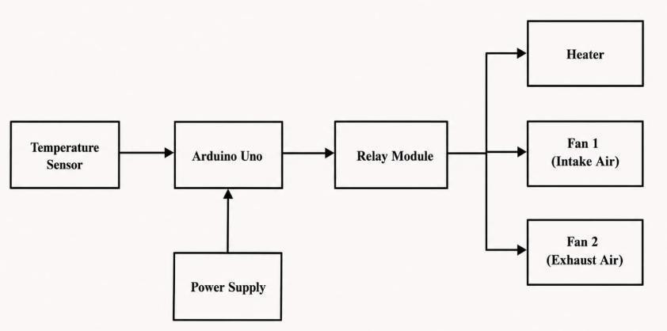

Figure 3.1 : Block Diagram of the Setup

The Arduino processes this data and compares it with predefined threshold values stored in the program. Based on this comparison, the Arduino generates control signals to operate the connected devices.These control signals are sent to the relay module, which acts as a switching interface between the low-power microcontroller and high-power electrical appliances. The relay module safely controls devices such as the heater and fan without directly

exposing them to the microcontroller.

When the temperature is below the lower limit, the relay activates the heater to increase the temperature inside the poultry shed. When the temperature exceeds the upper limit, the relay switches ON the fan to provide cooling and ventilation. When the temperature is within the desired range, both devices remain OFF, ensuring energy efficiency.

system is powered using a regulated power supply that provides stable voltage to the Arduino and sensor modules. Overall, the block diagram clearly illustrates a closed-loop control system where real-time environmental data is continuously monitored and automatically corrected to maintain optimal poultry farm conditions.

WORKING PRINCIPLE
The working principle of the Smart Poultry Farm Temperature Control System is based on continuous monitoring and automatic control of temperature inside the poultry shed using an Arduino Uno microcontroller. The system operates in a closed-loop manner where real-time temperature data is constantly measured, processed, and used for decision-making to maintain a suitable environment for poultry birds.

Initially, the temperature sensor placed inside the poultry shed continuously detects the surrounding temperature and sends the analog or digital signal to the Arduino Uno. The microcontroller reads this data and compares it with predefined threshold values programmed in the system. These threshold values define the minimum and maximum safe temperature limits required for proper poultry bird health and comfort.

When the temperature drops below the lower limit, especially during cold

night-time hours, the Arduino Uno activates the relay module connected to the heater. This turns ON the heater, which increases the temperature inside the poultry shed and restores it to a normal range. Once the desired temperature is reached, the heater is automatically switched OFF to prevent overheating and unnecessary power consumption.
Similarly, when the temperature rises above the upper limit due to environmental changes or heat buildup inside the shed, the Arduino activates another relay to turn ON the fan. The fan helps in cooling the environment and maintaining proper air circulation. When the temperature returns to the normal range, the fan is also switched OFF automatically.

This continuous process ensures that the poultry shed maintains a stable and comfortable temperature throughout the day and night. The automation reduces manual effort, improves accuracy in environmental control, and enhances the overall health, growth, and productivity of poultry birds.

ADVANTAGES OF THE PROPOSED SYSTEM
The Smart Poultry Farm Temperature Control System offers several advantages over traditional manual monitoring methods. The system continuously monitors environmental conditions and automatically controls the heater and ventilation fans without requiring constant human supervision. This helps maintain a stable and comfortable environment for poultry birds throughout the day and night.

The automatic temperature regulation feature reduces the risk of cold stress during winter seasons and prevents excessive heat during hot weather conditions. By maintaining the temperature within the recommended range, the system improves bird health, enhances growth performance, and reduces mortality rates.

The use of Arduino Uno and relay modules makes the system simple, reliable, and cost-effective. Since the heater and fans operate only when required, power consumption is minimized, resulting in improved energy efficiency and lower operating costs.
The system also reduces manual labor and enables farmers to focus on other farm management activities. Its modular design allows future expansion with additional sensors such as humidity sensors, gas sensors, water level sensors, and IoT-based remote monitoring features. Overall, the proposed system provides an efficient, economical, and practical solution for modern poultry farm automation.

HARDWARE REQUIREMENTS
The Smart Poultry Farm Temperature Control System consists of various hardware components that work together to monitor and control the environmental conditions inside the poultry shed. The hardware components are selected based on their reliability, low cost, and ease of implementation. The major components used in the system are Arduino Uno, DHT11 sensor, relay module, heater, intake fan, exhaust fan, and power supply unit.
The Arduino Uno serves as the central controller of the system. It receives data from the DHT11 sensor, processes the information, and controls the connected devices according to the programmed conditions.
The DHT11 sensor is used to measure the temperature and humidity inside the poultry shed. It continuously provides environmental data to the Arduino Uno for monitoring and decision-making.

The relay module acts as an interface between the Arduino Uno and the electrical appliances. It allows the microcontroller to safely control high-power devices such as the heater and fans.

The heater is used to increase the temperature inside the poultry shed whenever the temperature falls below the predefined threshold value. This helps protect poultry birds from cold stress during night-time and winter seasons.

The intake fan supplies fresh air into the poultry shed and helps maintain proper ventilation. It improves air circulation and supports a healthy environment for poultry birds.

The exhaust fan removes hot and stale air from the poultry shed. It helps regulate temperature and improves air quality by expelling excess heat and unwanted gases.

The power supply unit provides the required electrical power for the Arduino Uno, sensor modules, relay module, heater, and fans. A stable power supply ensures reliable operation of the entire system.

Arduino Uno
Arduino Uno is the main controller used in the Smart Poultry Farm Temperature Control System. It is based on the ATmega328P microcontroller and is responsible for processing sensor data and controlling the connected devices. The Arduino receives temperature and humidity readings from the DHT11 sensor and compares them with predefined threshold values. Based on the sensor data, it automatically controls the heater, intake fan, and exhaust fan through relay modules. The Arduino Uno is widely used because of its simple programming, low cost, reliability, and ease of interfacing with various sensors and electronic components.

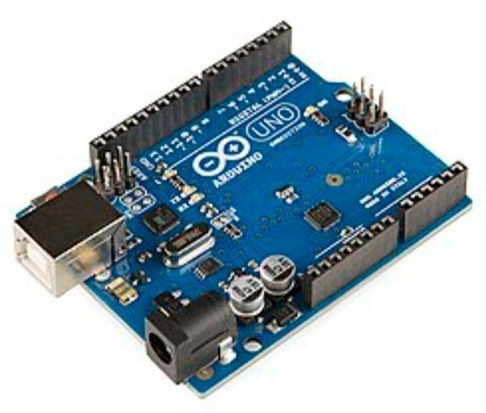

Figure 3.2 : Arduino UNO Board

DHT11 Sensor
The DHT11 is a digital sensor used to measure temperature and humidity inside the poultry shed. It continuously monitors environmental conditions and sends the measured data to the Arduino Uno microcontroller. The sensor provides accurate and reliable readings, enabling the system to maintain a suitable environment for poultry birds. Based on the temperature values received from the DHT11 sensor, the Arduino automatically controls the heater, intake fan, and exhaust fan through relay modules. The DHT11 is widely used due to its low cost, simple interfacing, low power consumption, and ease of integration with Arduino-based systems.

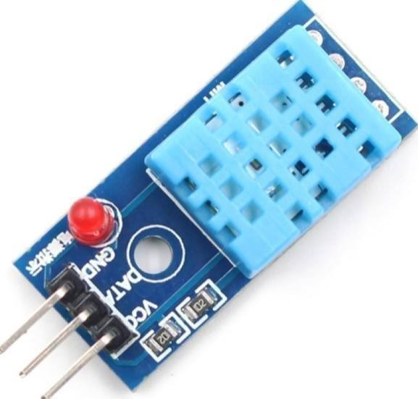

Figure 3.3: DHT11 Sensor

Relay Module
The relay module is an electronic switching device used to control high- power electrical appliances through low-power signals from the Arduino Uno. It acts as an interface between the microcontroller and devices such as the heater, intake fan, and exhaust fan. When the Arduino detects a change in temperature conditions, it sends control signals to the relay module, which switches the connected devices ON or OFF accordingly. The relay provides electrical isolation between the control circuit and power circuit, ensuring safe operation of the system. It is reliable, easy to interface, and widely used in automation and control applications.
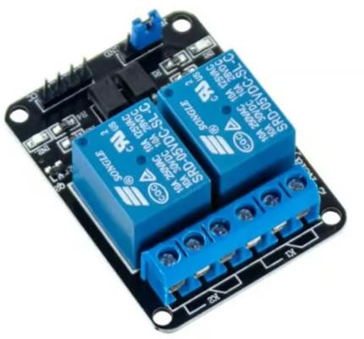

Figure 3.4 : Relay (Two Channel)

Heater
The heater is an important output device used in the Smart Poultry Farm Temperature Control System to maintain a suitable temperature inside the poultry shed. It is automatically controlled by the Arduino Uno through a relay module. When the temperature detected by the DHT11 sensor falls below the predefined threshold value, the Arduino activates the relay and switches ON the heater. The heater increases the surrounding temperature and provides a comfortable environment for poultry birds during cold weather and night-time conditions. This helps prevent cold stress, improves bird health, enhances growth performance, and reduces mortality rates.

Intake Fan and Exhaust Fan
The intake fan and exhaust fan are used to maintain proper air circulation and temperature control inside the poultry shed. Both fans are automatically controlled by the Arduino Uno through relay modules based on the temperature readings obtained from the DHT11 sensor. The intake fan draws fresh air from the outside environment into the poultry shed, helping to improve ventilation and maintain a healthy atmosphere for the birds. The exhaust fan removes hot, stale, and contaminated air from the shed, preventing heat buildup and ensuring proper airflow. Together, these fans help regulate temperature, improve air quality, reduce stress on poultry birds, and enhance overall farm productivity.

SOFTWARE REQUIREMENTS
Software plays an important role in the development and operation of the Smart Poultry Farm Temperature Control System. The software is responsible for programming the Arduino Uno, processing sensor data, and controlling the heater, intake fan, and exhaust fan based on environmental
conditions. The software requirements are selected to ensure easy development,

testing, and implementation of the system. The major software tools used in this project are the Arduino IDE and Embedded C programming language. These tools provide a simple and efficient platform for developing the control algorithm and monitoring the overall operation of the poultry farm temperature control system.

Arduino-IDE
Arduino IDE (Integrated Development Environment) is the software used to write, compile, and upload programs to the Arduino Uno microcontroller. It provides a user-friendly interface for developing embedded applications and supports various Arduino boards. In this project, Arduino IDE is used to create the control program that reads data from the DHT11 sensor and controls the heater, intake fan, and exhaust fan through relay modules. The software includes built-in libraries that simplify sensor interfacing and device control. Arduino IDE is widely used because it is free, easy to learn, and compatible with multiple operating-systems.

Embedded-C
Embedded C is the programming language used to develop the control logic of the Smart Poultry Farm Temperature Control System. It is a specialized version of the C language designed for programming microcontrollers and embedded systems. In this project, Embedded C is used to read temperature and humidity data from the DHT11 sensor, compare the readings with predefined threshold values, and control the relay module accordingly. The program enables automatic operation of the heater, intake fan, and exhaust fan based on environmental conditions. Embedded C provides high efficiency, flexibility, and reliability, making it suitable for real-time control applications.

CHAPTER 4 SYSTEM IMPLEMENTATION
4.1 INTRODUCTION
The implementation of the Smart Poultry Farm Temperature Control System involves integrating hardware and software components to achieve automatic environmental monitoring and control inside the poultry shed. The system is designed to continuously monitor temperature and humidity conditions using the DHT11 sensor and process the collected data through the Arduino Uno microcontroller. Based on the measured values, the system automatically controls the heater, intake fan, and exhaust fan through relay modules to maintain a suitable environment for poultry birds.

The implementation process includes sensor interfacing, relay control, programming the Arduino Uno, and testing the complete system under different environmental conditions. The DHT11 sensor continuously sends temperature and humidity data to the Arduino Uno. The microcontroller compares these values with predefined threshold limits and activates the required output devices accordingly. This automated operation ensures efficient temperature regulation, reduces manual intervention, and improves poultry health and productivity.

The implemented system provides a simple, reliable, and cost-effective solution for poultry farm automation and demonstrates the practical application of embedded systems in modern agriculture.

4 .2 CIRCUIT DIAGRAM AND IMPLEMENTATION

The circuit diagram represents the complete hardware implementation of the Smart Poultry Farm Temperature Control System. The Arduino Uno acts as

the central controller and is connected to the DHT11 temperature and humidity
sensor, relay module, heater, intake fan, and exhaust fan. The DHT11 sensor continuously monitors the environmental conditions inside the poultry shed and sends the measured data to the Arduino Uno for processing.
Based on the temperature values received from the sensor, the Arduino compares the readings with predefined threshold limits stored in the program. When the temperature falls below the minimum set value, the Arduino activates the relay module to switch ON the heater. This helps maintain a comfortable temperature inside the poultry shed and protects the birds from cold stress. Similarly, when the temperature exceeds the upper threshold value, the Arduino activates the intake fan and exhaust fan through the relay module to improve ventilation and reduce excess heat.
The relay module acts as an interface between the low-voltage Arduino circuit and the high-power electrical devices. It provides electrical isolation and ensures safe operation of the heater and fans. A regulated power supply is used to provide the required voltage to all components of the system. The complete implementation enables automatic temperature regulation, reduces manual monitoring efforts, improves poultry health, and enhances farm productivity. The system is simple, reliable, cost-effective, and suitable for practical deployment in small and medium-scale poultry farms.

CHAPTER 5 RESULTS AND DISCUSSION
  - HARDWARE IMPLEMENTATION

The Smart Poultry Farm Temperature Control System was implemented using Arduino Uno, DHT11 sensor, relay module, heater, intake fan, exhaust fan, and a regulated power supply. All hardware components were connected according to the circuit diagram and tested under different environmental conditions. The DHT11 sensor was placed inside the poultry shed model to continuously monitor temperature and humidity. The sensor transmitted real- time environmental data to the Arduino Uno for processing.
The Arduino Uno served as the central controller and executed the programmed control logic. Based on the sensor readings, the controller activated the relay module whenever the measured temperature crossed the predefined threshold values. The relay module functioned as an interface between the Arduino Uno and high-power devices such as the heater and fans.
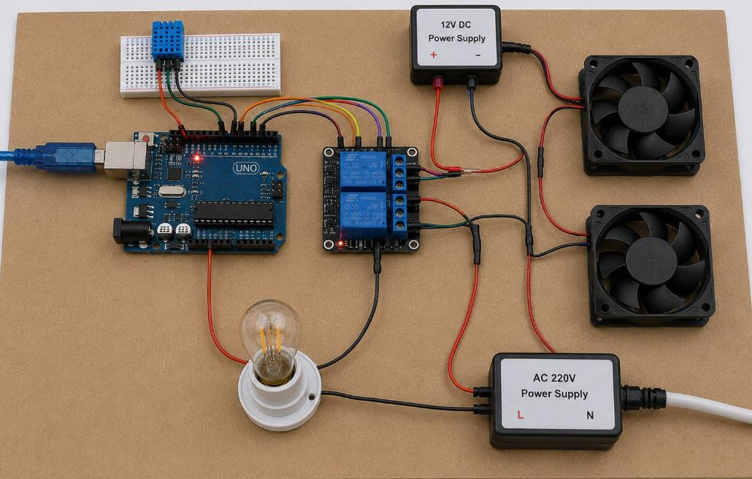

Figure 5.1 : Actual Hardware Setup

The heater was used to increase the temperature during cold conditions. Whenever the temperature fell below the lower threshold limit, the heater was automatically activated to maintain a comfortable environment for poultry birds. Similarly, the intake fan supplied fresh air into the poultry shed while the exhaust fan removed hot and stale air from the enclosure. These fans were activated whenever the temperature exceeded the upper threshold limit.

The complete hardware setup was assembled on a prototype board and powered using a regulated power supply. All components operated successfully without interruption during testing. The implementation demonstrated the practical feasibility of the proposed system and confirmed its capability to provide automatic environmental control for poultry farming applications.
The system was tested multiple times during different periods of the day to observe its performance under varying environmental conditions. The results confirmed that the hardware components worked together effectively to maintain stable temperature conditions inside the poultry shed.

EXPERIMENTAL RESULTS AND ANALYSIS
The experimental evaluation was conducted to verify the effectiveness of the Smart Poultry Farm Temperature Control System. The system was operated continuously and the behavior of the heater, intake fan, and exhaust fan was observed under different temperature conditions.
During cold environmental conditions, the DHT11 sensor detected low temperatures and transmitted the readings to the Arduino Uno. The controller compared the measured values with the predefined threshold temperature. Whenever the temperature dropped below the lower limit, the heater was automatically activated. This helped maintain a comfortable environment for

poultry birds and prevented cold stress.
When the environmental temperature increased beyond the upper threshold value, the intake fan and exhaust fan were activated automatically. The intake fan supplied fresh air while the exhaust fan removed hot air from the poultry shed. This process improved air circulation and reduced excessive heat accumulation inside the enclosure.
The operation of the system was monitored throughout the testing period. The response time of the Arduino controller was found to be satisfactory. The relay module successfully switched the heater and fans ON and OFF based on the received sensor data. The system maintained stable operation and showed no major performance issues.

TEST | Temperature(°C) | Heater | Intake Fan | Exhaust Fan
1 | 22 | ON | OFF | OFF
2 | 24 | ON | OFF | OFF
3 | 27 | OFF | OFF | OFF
4 | 31 | OFF | ON | ON
5 | 33 | OFF | ON | ON
6 | 29 | OFF | OFF | OFF
7 | 23 | ON | OFF | OFF

Table 5.1 : Result Temperature Control System

The obtained results indicate that the proposed system effectively responds to environmental changes. The automatic switching mechanism

reduced the need for manual supervision and improved overall farm management efficiency.

Graph Analysis
The temperature variation graph clearly shows the environmental changes occurring throughout the day. During early morning and late-night hours, the temperature remained below the desired level, causing the heater to operate automatically. During afternoon hours, the temperature increased significantly, resulting in the activation of the intake and exhaust fans.

The graph confirms that the control algorithm successfully maintained temperature within the acceptable range and provided suitable environmental conditions for poultry birds.

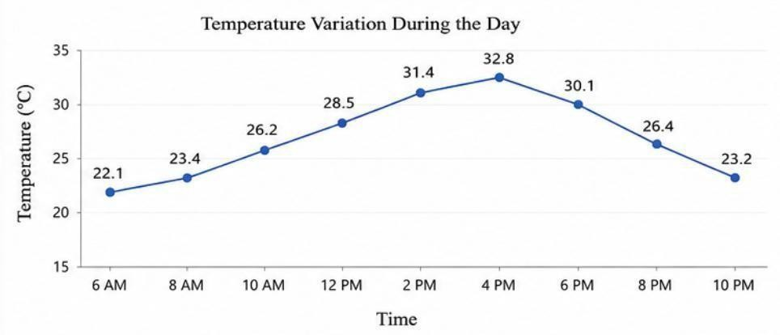
Figure 5.2 : Temperature Variation Graph

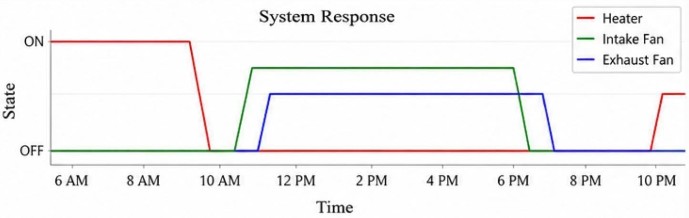
Figure 5.3 : System Response

DISCUSSION
The experimental results demonstrate that the Smart Poultry Farm Temperature Control System performs effectively under different environmental conditions. The DHT11 sensor provided reliable temperature and humidity measurements throughout the testing period. The Arduino Uno processed the sensor data accurately and controlled the output devices according to the programmed conditions.
The heater successfully maintained the required temperature during cold weather conditions, preventing sudden temperature drops inside the poultry shed. The intake fan and exhaust fan provided effective ventilation and temperature regulation whenever excessive heat was detected. This ensured a comfortable and healthy environment for poultry birds.
One of the major advantages observed during testing was the reduction in manual monitoring requirements. Farmers no longer need to continuously observe environmental conditions because the system performs temperature regulation automatically. This reduces labor requirements and improves operational efficiency.
The system also demonstrated good energy efficiency. Since the heater and fans operate only when required, unnecessary power consumption is avoided. This helps reduce electricity costs and improves the economic feasibility of the system.
The proposed system is particularly beneficial for poultry farms operating during winter seasons when temperature fluctuations can significantly affect bird health. By maintaining stable environmental conditions, the system reduces stress, improves growth performance, and minimizes mortality rates.

Overall, the Smart Poultry Farm Temperature Control System successfully achieved its objectives and proved to be a reliable, cost-effective, and practical solution for poultry farm automation. Future improvements may include IoT-based remote monitoring, mobile application integration, cloud data storage, and advanced environmental sensing capabilities to further enhance system performance and usability.

CHAPTER 6 CONCLUSION AND FUTURE SCOPE
  - CONCLUSION

The Smart Poultry Farm Temperature Control System was successfully designed, implemented, and tested to provide automatic environmental control inside a poultry shed. The system continuously monitors temperature and humidity conditions using the DHT11 sensor and processes the collected data through the Arduino Uno microcontroller. Based on the measured values, the system automatically controls the heater, intake fan, and exhaust fan through relay modules to maintain a suitable environment for poultry birds.
The experimental results confirmed that the system responds effectively to changes in environmental conditions. During low-temperature conditions, the heater was automatically activated to maintain the required temperature, while the intake fan and exhaust fan operated efficiently during high-temperature conditions to provide proper ventilation. This automatic operation reduced the need for continuous manual monitoring and improved the overall management of the poultry farm.
The proposed system offers several advantages including low cost, simple implementation, energy-efficient operation, improved poultry health, reduced mortality rates, and enhanced productivity. By maintaining a stable environmental temperature, the system helps create a comfortable living condition for poultry birds and supports better growth performance. The project successfully demonstrates the application of embedded systems and automation technology in modern poultry farming and provides a practical solution for environmental management in small and medium-scale poultry farms.

FUTURE SCOPE
Although the developed system effectively controls temperature inside the poultry shed, several improvements can be incorporated in the future to enhance its functionality and performance. Additional sensors such as gas sensors, ammonia sensors, water level sensors, and feed monitoring sensors can be integrated to provide comprehensive poultry farm management.
The system can be upgraded with IoT technology to enable remote monitoring and control through mobile applications and cloud platforms. Farmers can receive real-time alerts and monitor environmental conditions from any location using smartphones or computers.
Future versions of the system may include automatic data logging and cloud storage facilities for maintaining historical records and analyzing farm performance. Machine learning and artificial intelligence techniques can also be integrated to predict environmental changes and optimize poultry farm operations.
Solar-powered operation can be implemented to reduce electricity consumption and improve sustainability. Advanced control systems with multiple environmental parameters can further enhance poultry health, productivity, and energy efficiency. These improvements will transform the system into a fully automated smart poultry farm management solution suitable for large-scale commercial poultry farming.

REFERENCES

    - Banzi, M. and Shiloh, M. (2022), Getting Started with Arduino, 4th Edition, Maker Media Publications, USA.

    - Kumar, R., Sharma, P., and Verma, S. (2023), Arduino-Based Smart Poultry Farm Temperature Monitoring and Control System, International Journal of Embedded and IoT Systems, Vol. 10, No. 3,
pp. 115–132.

    - Kumar, S. and Patel, R. (2021), Arduino-Based Automated Temperature Control System for Poultry Farms Using Sensors and Relays, International Journal of Engineering and Technology Research, Vol. 10, No. 2, pp. 98–116.

    - Kumar, V. and Singh, R. (2020), Smart Farming Using Embedded Systems and IoT Technologies, International Journal of Smart Agriculture, Vol. 7, No. 1, pp. 45–58.

    - Monk, S. (2021), Programming Arduino: Getting Started with Sketches, 3rd Edition, McGraw-Hill Education, New York.

    - Patel, H., Shah, D., and Mehta, K. (2022), Automation in Poultry Farming Using Sensor-Based Monitoring Systems, International Journal of Agricultural Technology and Innovation, Vol. 11, No. 2,
pp. 87–102.

    - Rahman, M., Islam, T., and Ahmed, N. (2021), Wireless Sensor Network Based Smart Poultry Farm Monitoring System for Environmental Control, Journal of Agricultural Automation and Engineering, Vol. 8, No. 3, pp. 143–162.

    - Singh, A., Patel, M., and Gupta, R. (2022), IoT-Based Smart Poultry Farm Environmental Monitoring System Using Sensors and Cloud Computing, International Journal of Internet of Things and Smart Systems, Vol. 9, No. 4, pp. 201–218.

